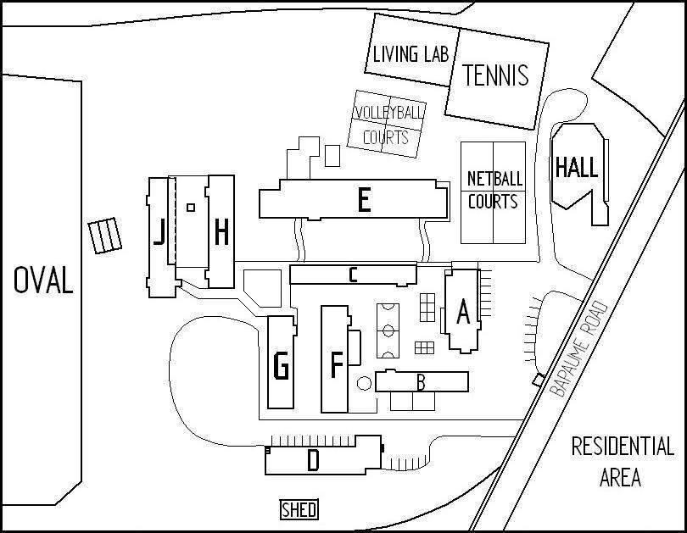
Volleyball
Shed
Key

A MAIN OFFICE, ADMINISTRATION | F ENGLISH
B LANGUAGES,  GUIDANCE OFFICER, CHAPLAIN  CANTEEN, UNIFORM SHOP,  RESOURCE HIRE ROOM | G BUSINESS EDUCATION,  HPE, GYM
C HOME ECONOMICS  YOUTH HEALTH NURSE | H SOCIAL SCIENCE, HPE  ART, LIBRARY  J MATHEMATICS, MUSIC  MULTI-MEDIA ROOM
D APPLIED TECHNOLOGY | L HALL
E SCIENCE | VS VOLLEYBALL SHED
Volleyball
Shed

